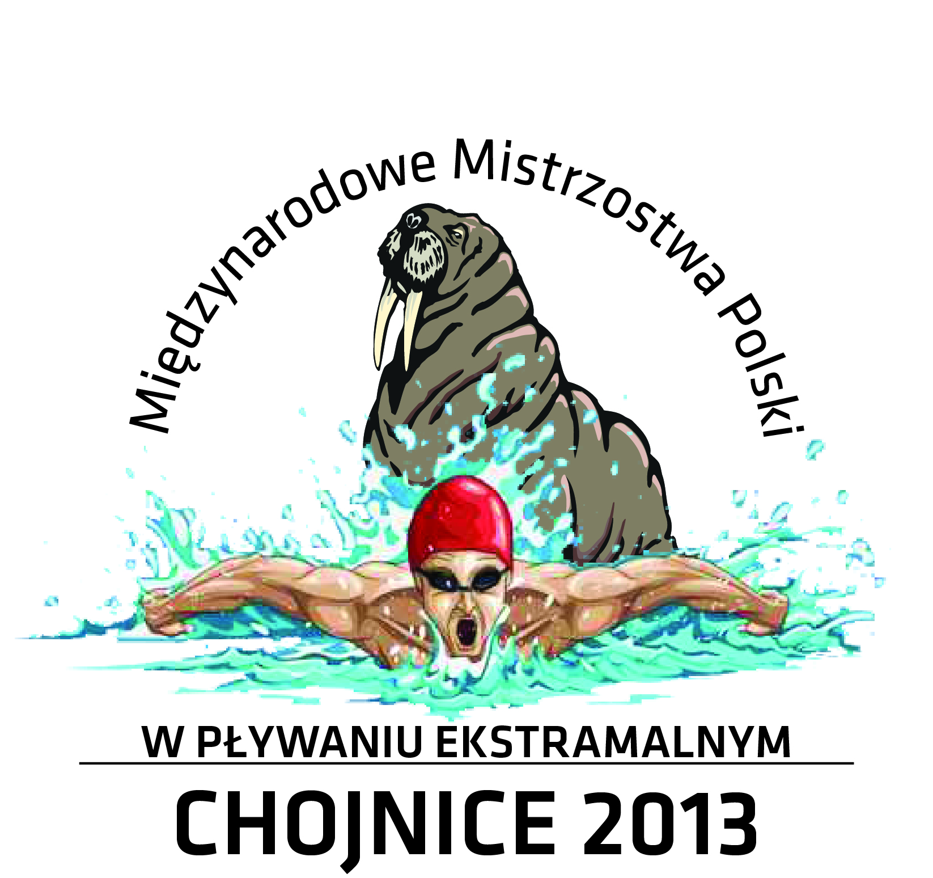

1st OPEN INTERNATIONAL POLISH SWIMMING CHAMPIONSHIPS
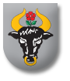
IN ICE COLD WATER

CHOJNICE/ CHARZYKOWY
06 – 08 December 2013 r.

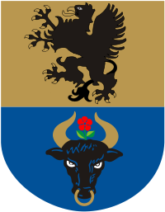

Patronage: Mayor of Chojnice City
Starost of Chojnicki County
Alderman of Chojnice Commune

Organisers: Centrum Park Chojnice LLC
Gdanski Klub Twardziela Lech-Mors
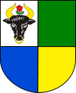

Chairman of the Organising Committee : Mariusz Paluch

Director: Ryszard Sielski

Location: Charzykowskie Lake, temp. of water +4°C

Participants: People aged 18 years and over.

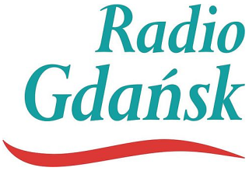


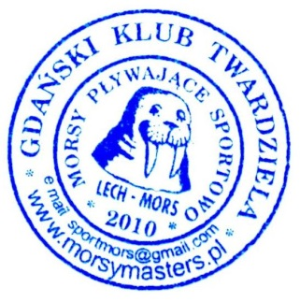
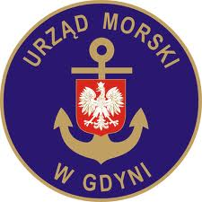
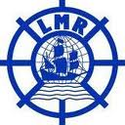
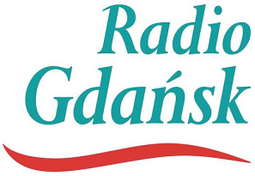

• Rules: Start in two individual event and relay.
The provisions of FWS.
The competition will be conducted in accordance with the program
and by age categories:
- „0” 18 – 24
- „A” 25 – 29
- „B” 30 – 34
- „C” 35 – 39
- „D” 40 – 44
- „E” 45 – 49
- „F” 50 – 54
- „G” 55 – 59
- „H” 60 – 64
- „I” 65 – 69
- „J” 70 – 74
- „K” 75 – 79
- „L” 80 – 84
- „M” 85 – 89
- „N” 90 – 94
Relay will be held by age category, which designates the sum of years
relay participants:
100, 120, 160, 200, 240, 280, 320, 360.

• Deadline for submission of applications: 31.10. 2013 r.

• Necessary documents:
- Participation form (in the attachment)
- Statement of health form (in the attachment)

• Registration: application should be sent to tomek.zwiejski@gmail.com and
alexander1944@wp.pl or submitted for registration on the day of the race
[registration on the day of the race doubles the fee]
• Entry fee: 65 PLN (15€)
with hotel and catering 06.12 – 300 PLN (75€)
with hotel and catering 7.12 – 240 PLN (60€)
(the charge of the hotel and catering provide recreation
and entertainment program).
Account number: 33 1160 2202 0000 0000 6464 0816 €
Account number: 13 1160 2202 0000 0000 6464 0303 PLN

• Awards: Individual competitions – I,II,II – medals and diplomas
Competitions relay events – I,II,III – medals and diplomas
For all participants – commemorative medals
Special Awards – trophy for the best club by medal ranking.
Prizes.

CAUTION: When paiyng for title transfer,please state the name, surname and
the related amount.
(EXAMPLE: John Smith;15€)

PROGRAM

Friday 06.12.2013 – Accompanying event – Cabaret

Saturday 07.12.2013
10:00 Registration
12:00 Grand opening event and start of competition
- Women – freestyle 50m
- Men – freestyle 50m
- Women – breaststroke 25m
- Men – breaststroke 25m
- Relay – 4x25m. mix style
Integration party – presentation of medals

Sunday 08.12.2013
10:00 Start of competition
- Women – breaststroke 50m
- Men – breaststroke 50m
- Women – freestyle 25m
- Men – freestyle 25m
- Relay – 4x25m. mix style
Presentation of medals and the closing ceremony of the championships.

