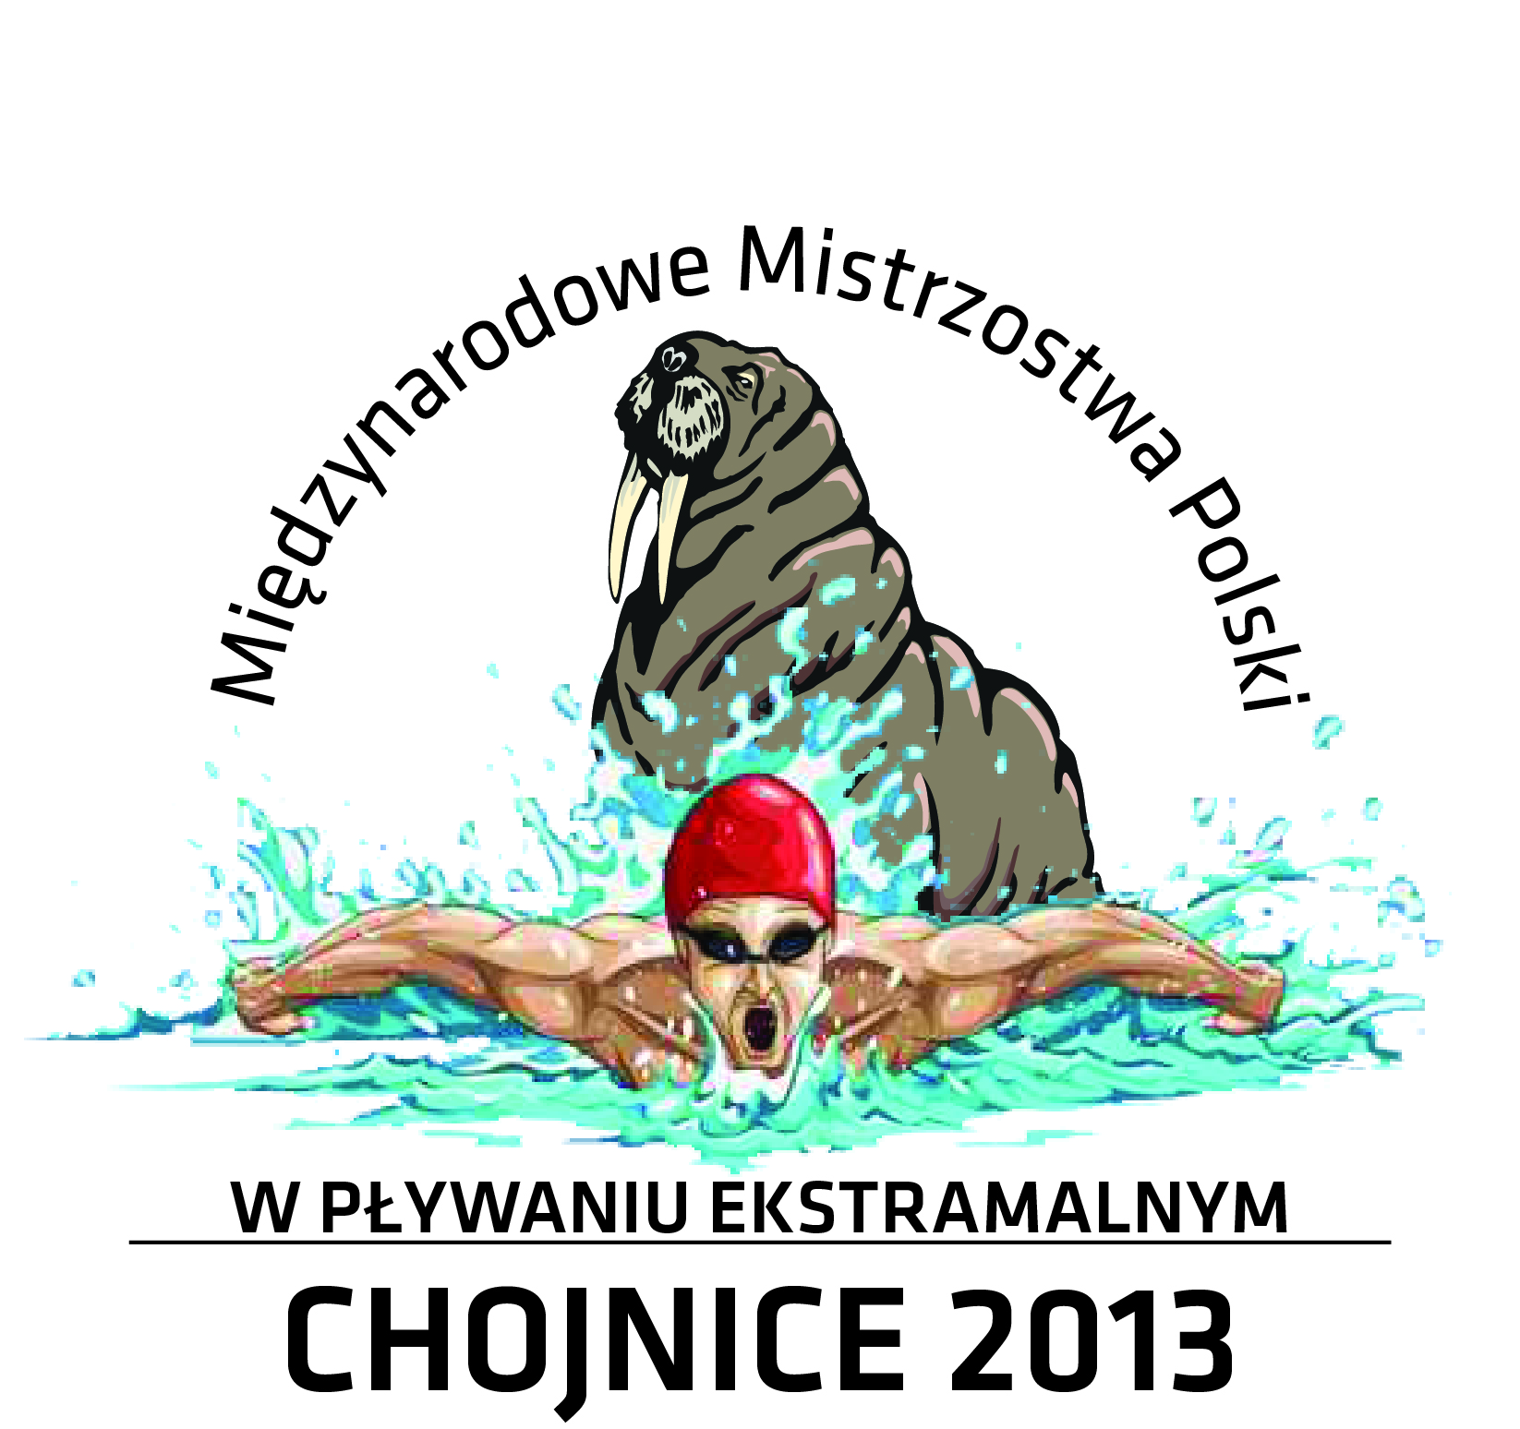

GOOD HEALTH STATEMENT

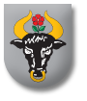
I attest to the fact that I am in good physical condition
and I am physically able to participate in the activities involved in the 1st Open International Polish Swimming Championships in Ice Cold Water in Chojnice and I am free from any disease prohibiting me from participation in these championships at this time.

Should any of the above conditions change, I will promptly notify the organizers.

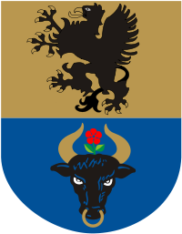
Date: ………………………………………………………….

Name: …….………………………………………………….

Surname:.. ……………………………………………………

Passport/ID: ……………………..…………………………...

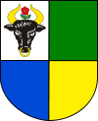
Signature: …………………………………………………….

CHOJNICE, December 6th – 8th, 2013

